**Day 1: The Absolute Basics of HTML 🏗️**

Welcome to your first day of web development! Today, we're starting with **HTML**, which is the fundamental building block of every single website you've ever visited.

**What is HTML?**

Think of a house. Before you can paint the walls (CSS) or install an electric garage door (JavaScript), you need to build the frame, the walls, and the roof. **HTML is the frame and structure of a webpage.**

HTML stands for **H**yper**T**ext **M**arkup **L**anguage. Let's break that down:

* **HyperText**: This refers to the "links" that connect web pages to one another, forming the "web."
* **Markup Language**: This means you use a special syntax to "mark up" your plain text to tell the browser how to display it. For example, you mark some text as a heading, some as a paragraph, and some as an image. It describes content; it's not a programming language with logic.

**The Building Blocks: Tags, Elements, and Attributes**

HTML works by using "tags" to wrap around your content.

* **Tags**: These are keywords surrounded by angle brackets, like <p>. They usually come in pairs: an **opening tag** (<h1>) and a **closing tag** (</h1>). The closing tag has a forward slash (/).
* **Elements**: An element is the complete package: the opening tag, the content inside, and the closing tag.

<p>This is the content of the paragraph element</p>

* **Attributes**: These provide extra information about an element. They are always included in the **opening tag** and are made up of a name and a value in quotes, like name="value". We'll see an example with links later.

**The Basic HTML Document Structure**

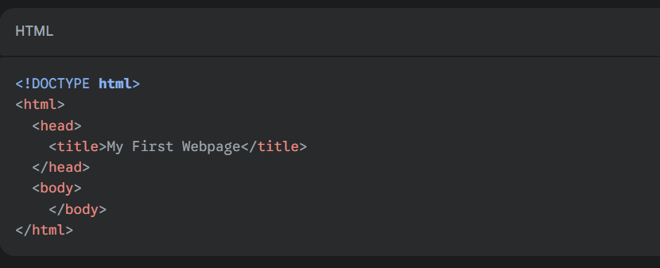Every HTML document, no matter how complex, follows this same basic structure. Think of it as the boilerplate or template you'll start every project with.

Let's look at each line:

1. **<!DOCTYPE html>:** This is a required declaration. It's always the very first line and it tells the browser, "Hey, I'm an HTML5 document!" The <!DOCTYPE> declaration represents the document type, and helps browsers to display web pages correctly.
   * It must only appear once, at the top of the page (before any HTML tags).
   * The <!DOCTYPE> declaration is not case sensitive.
   * The <!DOCTYPE> declaration for HTML5 is:

<!DOCTYPE html>

1. **<html>:** This is the **root element**. All other elements on the page are nested inside this one.
2. **<head>:** This section contains **metadata**—data about your webpage. This information is not displayed on the actual page. It includes things like the page title, links to stylesheets (CSS), and character sets.
3. **<title>:** The only thing you'll see from the <head> section. The text here appears in the browser tab.
4. **<body>:** This is where the magic happens! **All visible content**—headings, paragraphs, images, links, forms—goes inside the <body> tags.